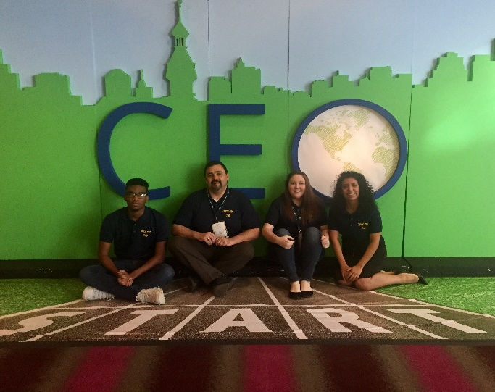
Collegiate Entrepreneurship Organization (CEO)
National Conference, Tampa FL Oct 26-28, 2017
http://www.c-e-o.org/page/2017conf

As Assistant Faculty Advisor of UNCG’s CEO Entrepreneurship Club, I accompanied a group of students to the conference with over 700 attendees from 100 colleges and universities across the United States. The event included several Entrepreneur keynote speakers, a selection of break-out sessions on a variety of topics, and pitch competition with a $5,000 prize.

Quotes from Students that Attended

“The CEO 2017 conference was a great learning experience. The speakers shared a lot of incredible information along with providing inspiration for all the aspiring entrepreneurs. My favorite part of the conference was having the opportunity to meet students from all over the United States who already have their own businesses. It was also great to meet other chapters and find out what type of events and initiatives their chapter has going on”

“I think that overall this experience was more than I could’ve hoped for, and it helped me realize more about myself. I was also able to get closer with my fellow members, and that makes me happier as well, because it’ll be able to bring the club together as a whole.”
“This was my second year attending the Collegiate Entrepreneurs’ Organization National Conference. After attending last year and this year’s conference, I feel that not only have I learned a plethora of invaluable information, but I was able to meet successful entrepreneurs’ and other students who are entrepreneurs or aspiring to be one, one day. Attending this conference for me is not only fun, but also valuable to any student.”
Chapter Improvement Suggestions
99% of our club is mainly business majors and while that is great for them, we need to bring in other majors so that we can have a much bigger diversity with other ideas that business majors may not think of. Something I noticed at the pitches as well, is that a lot of the students partnered with science and engineering majors to create their product or app. Even though UNCG doesn’t have an engineering program, I believe bringing in more computer science majors would be beneficial

I learned that some chapters have figured out ways to run all the campus businesses to generate income for the whole club, or that some of them ran outside businesses, in conjunction with their campus business to be able to invest in both their own benefits, and still generate capital for the club. There were clubs with over 100k in revenue yearly.

We need to have more hands out activities or opportunities for members to practice different aspects of entrepreneurship. Currently all we do is have guest speakers. This is not very engaging and throughout the semester our attendance in meetings has decreased.

The session for chapter development on Thursday were also very helpful. Below I have listed some of the ideas and tips that were shared by the presidents of CEO Chapters that are bigger and more active.

Social Media & email Tips
- Live stream speakers and activities that happen during CEO meetings on Facebook
- Share internship opportunities through social media
- Member takeover – have different members take over the social media site to highlight the leadership roles and community involvement they have
- Internship takeover – post information about what a day in the life of an intern would be like in working at a specific place
- Use mail chimp to track how many of the members open un emails
- Make emails fun by adding jokes, memes, or other images to make it seem more appealing rather than just reading a formal email
- Promote entrepreneurship events from other organizations to members
- Get feedback from members on what type of events they would like to see
- Send out weekly emails with updates
- Send a follow up email after every CEO Meeting

Marketing Campaign Ideas
- Face of Entrepreneurship – highlight local entrepreneurs each week on social media sites by sharing their story, business and tips they may have to aspiring entrepreneurs
- Meet the Members Mondays – introduce a CEO member through social media sites. Post about their major, involvement in the community and future aspirations
- Inspirational Wednesdays – Share an inspiration quote for all the aspiring entrepreneurs
- Informational Thursday – share news articles, events, or new products from entrepreneurs or related to innovation

Event Ideas
- Tea Time – go out and set up tours with local small businesses and entrepreneurs, learn about their business and interact with community members
- Networking Events – host a networking event in a local collaborative work place and invite members from the community, university, CEO alumni and members, and entrepreneurs
- Member Bonding Events – do social activities outside of club meetings to get members to get to know each other on a personal level
- Entrepreneur Expo – invite local startups and businesses to set up expo tables, invite members from the community and school to learn about these businesses
- Have an idea pitch competition and invite college students from other universities to participate
- Have joint events with other organizations on campus to try and recruit their members to CEO (organizations related to technology, innovation, STEM, professionalism, leadership, business, marketing, sales, IT, communications, public speaking, finance, accounting)
- Have a business plan completion
- Attend events that other entrepreneurship organizations are hosting (i.e. Collab, HQ Greensboro, UNCG Entrepreneurship Center)

