ONCE UPON A TIME IN YOUR FUTURE
JOINING THE FORCES OF CREATIVITY AND ENTREPRENUERSHIP
IN YOUR DESTINY

Stoel Burrowes
Assistant Professor
The University of North Carolina at Greensboro
Department of Interior Architecture s_burrow@uncg.edu
114 Gatewood Studio Arts Building
Office Hours: T & TH 1:45 – 2:30

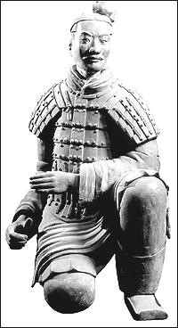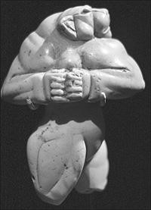
Mary Altaffer/AP Art Archive, London/ Courtesy of Dagli Orti Phaidon Press

“…Five hundred years is a long time, and I don’t expect many of the people I interview will be known in the year 2500.
Christopher Alexander may be an exception.”
David Creelman, author, Interviewer and Editor Knowledge Manager, HR magazine, Toronto

DESCRIPTION
This course explores the cognitive skills of design and entrepreneurship together. Students interested in innovation and creativity and bringing these ideas to market will benefit. Through reading, discussion, lecture, research assignment, journal entry and project presentation students will learn the specific application of both design and business ideas in their work. Studying philosophy, creation and application will bring together sometimes disparate strands of expertise. Attention will be focused in the class through projects and presentations on the student’s understanding of design and entrepreneurship.
This course emphasizes both the material/physical manifestation of design as well as its philosophical alter-ego. Emphasis will be shared with attention to business planning and starting. The reality of the business environment – its practicality and functional demands – adds multiple layers of significance to any work. Discussion with local entrepreneurs and international case study will engage students ‘real world’ practice. The premise being that the design environment is real – it is dwelled with, created, used and it sits, also, in time and space.
The content of this course satisfies General Education Core Global (GL) Marker curriculum requirements.

PREREQUISITES
There are no pre-requisites for this course. A keen sense of interest in the built environment is recommended.

ACADEMIC REGULATIONS AND POLICIES/UNIVERSITY REQUIREMENTS
It is imperative that students become familiar with the academic regulations and policies, as well as, the University' requirements found in sections 4 and 5 of The University of North Carolina at Greensboro Undergraduate+Bulletin.

ATTENDANCE
Attendance is absolutely mandatory during class hours. Absence from more than one class may affect your grade. Professor should be notified before class of absence, if possible. Student is responsible for work missed.

ADDITIONAL REQUIREMENTS
Students with disabilities requiring special classroom accommodation should notify Professor Burrowes in the first week of class.

LEARNING OUTCOMES
Students taking ENT/IAR 321 are expected to progressively build, through weekly readings, lectures and projects, a strong visual literacy of designed objects along with understanding of business development and an entrepreneurial mindset. Students will be expected to understand entrepreneurship and how design development is impacted. Understanding and literacy will be demonstrated through small group discussion, tests, writing project and presentation projects.
On completion of this course, students will be able to:
- Distinguish design as a creative product of culture, and identify and use the design properties demonstrated.
- Demonstrate an understanding of right-brain and left-brain directed thinking.
- Develop sensitivity toward the variety of qualities, cultures and worldviews that have transformed the design environment through time. 4) Develop language facility to analyze visual and written evidence and documentation of a deeper awareness of the interactions of design and entrepreneurship in society.
5) Demonstrate the ability to identify an entrepreneurial opportunity and the organization of ideas and plans into action in a business model. 6) Evaluate diverse opportunities available in the merging of design and entrepreneurship.
7) Evaluate the skill sets needed to succeed in both design and entrepreneurship.

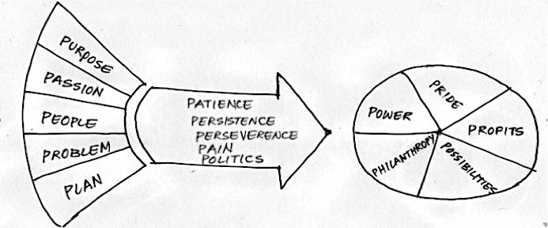

STRATEGIES
Weekly reading assignments will be discussed and students will be
expected to keep a Journal of reading and lecture/discussion notes. The Journal can include any other materials gathered and/or notes/sketches that are important to this course. Your completion of assigned reading with quizzes and essay graded through Mobius Slip along with participation in discussion is a primary responsibility. Guest Lecturers, entrepreneur interviews, and production of a product for sale at the Spartan Trader Retail Store will all be projects in this class. Over the course of the semester students will be quizzed and tested with a final exam. A research paper, the investigation/research-project, will be an essay where key theoretical premises, explored in the lectures and readings, can be investigated and engaged through objects, environments and culture. Understanding of the principles and clear use of the vocabulary of design and entrepreneurial enterprise should be demonstrated. Students will, also, produce a 10-15 minute presentation scheduled during the semester.

EVALUATION

Approximate Percentage Weights:
Quizzes & Papers |  | 40%
Spartan Trader Project |  | 10%
Business Model presentation |  | 10%
Research Presentation & Paper |  | 20%
Final Exam |  | 10%
Participation, Journal & Attendance |  | 10%
TOTAL: |  | 100%

Late work will be marked down one full letter grade for each assigned class meeting it is late and will not be accepted after 2 class periods from the project’s assigned due date or after the scheduled class final exam time, which ever is first.
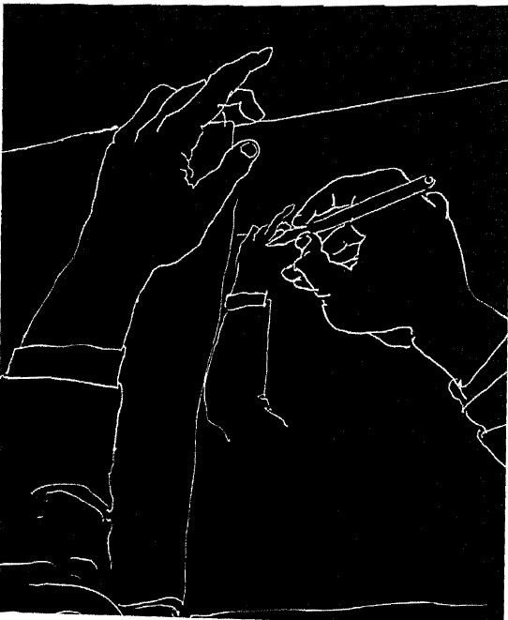
All work completed in this course will meet the requirements of the UNCG Honor Code. Your grade will be based on University guidelines; refer to The University of North Carolina Greensboro Undergraduate Bulletin.

“Excellent work” (receiving the grade “A”) requires independent thinking and to receive this grade, you must bring qualities to your work “above and beyond”.
- – high quality work beyond stated requirements: “excellent”
- - quality work satisfying requirements: “very good”
- – work satisfies requirements: “good”
- – minimally acceptable: “needs more effort”
F – unacceptable

